*Answers for reverse Challenge*

Ideally you should put a dot on each of the problems on page 2 after printing a copy back to back, and then photocopy more double sided copies. They will need to be cut up as they are paired up with the solution as printed.

When you pair up all the cards without a dot and you turn them over you will get the pairs from page 2 recreated as below.

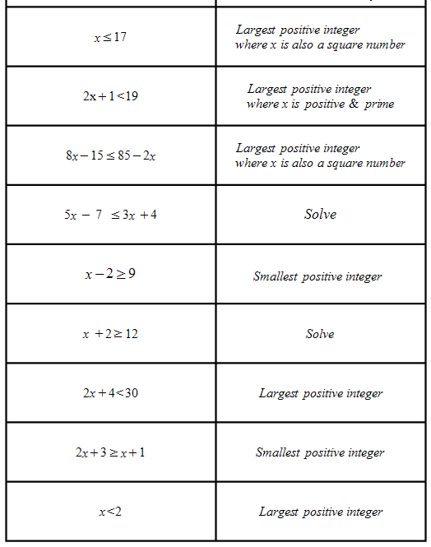The solutions are shown on the right and the first letter of the answer (say t for two) is then converted using the decoding sheet to give the letters that make up the word ISOSCELES

|  |
| --- |
| x = Sixteen  S decodes to E |
| x = Seven  S decodes to E |
| x = Nine  N decodes to O |
| x = Five point Five  F decodes to I |
| x = Eleven  E decodes to L |
| x = Ten  T decodes to S |
| x = Twelve  T decodes to S |
| x = - Two  T decodes to S |
| x = One  O decodes to C |